2024 Holiday Calendar

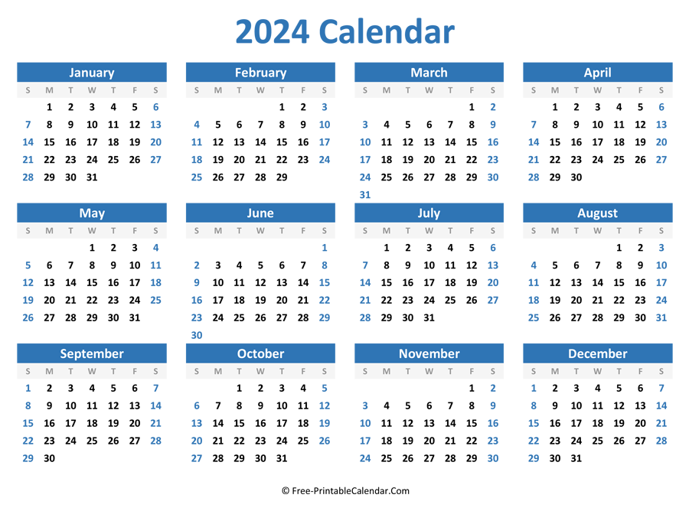
JANUARY 1, 2024 | Courthouse Closed in Observance of New Year’s
FEBRUARY 19, 2024 | Courthouse Closed in Observance of President’s Day
March 29, 2024 | Courthouse Closed in Observance of Good Friday
May 27, 2024 | Courthouse Closed in Observance of Memorial Day
July 4 & 5, 2024 | Courthouse Closed in Observance of Independence Day
September 2, 2024 | Courthouse Closed in Observance of Labor Day
OCTOBER 14, 2024 | Courthouse Closed in Observance of Columbus Day
NOvember 11,2024 | Courthouse Closed in Observance of Veterans Day
November 27,28 & 29, 2024 | Courthouse Closed in Observance of the Thanksgiving Holiday
December 24 ,25, 26, & 27 2024 | Courthouse Closed in Observance of the Christmas Holiday

